Links for practicing composite shapes, nets of 3D shapes, volume of prisms.

Shaded area https://www.liveworksheets.com/node/6888475

Area of composite figures https://www.liveworksheets.com/worksheet/en/math/1210954

Surface area of prisms https://www.liveworksheets.com/worksheet/en/math/1305349
Example:
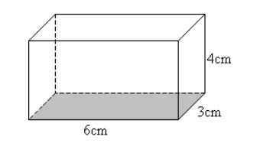
Face 1: 6 cm x 3 cm = 18 ${cm}^{2}$
Face 2 6 cm x 3 cm = 18 ${cm}^{2}$
Face 3: 6 cm x 4 cm = 24 ${cm}^{2}$
Face 4: 6 cm x 4 cm = 24 ${cm}^{2}$
Face 5: 3 cm x 4 cm = 12 ${cm}^{2}$
Face 6: 3 cm x 4 cm = 12 ${cm}^{2}$
Surface area = 18 + 18 + 24 + 24 + 12 + 12 = 108 ${cm}^{2}$

Nets of 3D shapes https://www.liveworksheets.com/worksheet/en/math/229647

Volume of prisms https://www.liveworksheets.com/node/5885458

